Leave a lasting legacy and add your name to the El Centro College Giving Tree.

THANK YOU
for supporting El Centro College!

For more information or questions, please contact
El Centro College at
maggielo@dcccd.edu or

214-860-2015.

Please return completed forms and checks by mail to:

El Centro College,
c/o Maggie Lopez, A223 801 Main St.
Dallas, TX 75202

Orders may also be placed online at: https://www.foundation.dcccd.edu/employee- giving-campaign/ecc-giving-priorities

Proceeds from the El Centro College Giving Tree will benefit the El Centro College Scholarships and funds at the DCCCD Foundation. Gifts are tax- deductible within the limits allowed by law under the Internal Revenue Service Exemption (DAL:EO:73-690) issued under authority of Section 501(c)(3) of the IRS Code.
Dedicate a Leaf on The El Centro College

Giving Tree

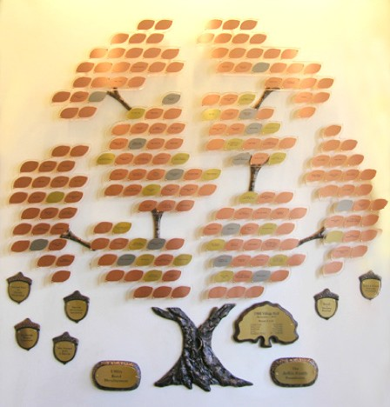

The Giving Trees will be a permanent design element at both the El Centro College Downtown Campus and at the West Campus locations.

Every leaf on the trees can be dedicated to a faculty member, staff or administrator, student or alumni, program, or college partner as a way to commemorate those who have contributed to El Centro College.
Yes, I am interested in leaving a lasting mark at El Centro College!

Name: Address: City:_____________________State,_____________Zip: _______
Phone:

Email:

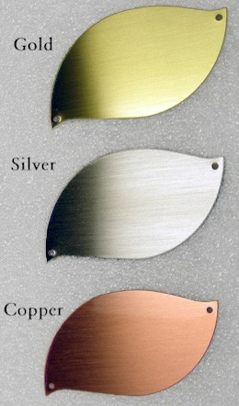
Sample Leaf:
Leaf Color:
o Gold - $500 o Silver - $200 o Copper - $100

Leaf Location:
o Downtown Campus o West Campus

Message you wish to be engraved (up to 50 characters and spaces), please print:*

Actual Size: 3.5” from left to right, and 2.25” tall

Leaves may be engraved up to 50 characters and spaces and come in three color options.

Additionally, you designate which location you would like your leaf installed (Downtown or West).

The trees are located for viewing in the lobbies of El Centro B building downtown and West Campus.

* An email confirmation of the message will be sent to you for review upon receipt to ensure correct spelling.

o Please send a personalized letter to the honoree:
Name:_________________________________________________ Address:_______________________________________________City:_____________________State,_____________Zip: ________
From:_________________________________________________
Payment Options:
o Check enclosed.
(Made payable to the DCCCD Foundation)
o Credit Card Payments may be made online at: https://www.foundation.dcccd.edu/employee-giving- campaign/ecc-giving-priorities
Leaves may also be purchased as part of the Employee Giving Campaign through the Foundation’s website.
Please return completed forms with checks to:
El Centro College,
c/o Maggie Lopez
801 Main Street
Dallas, TX 75202

